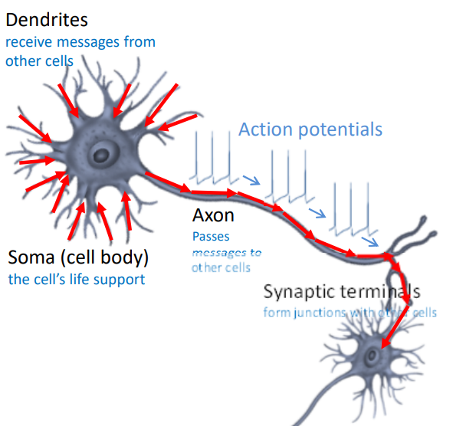Lecture 7 – Excitable tissue, neural interfaces and bionic eyes

PART 1: Bionic Neurophysiology

* STRUCTURE OF A NEURON
  + Dendrites
    - Reach out/add and summarize messages and signals from other cells
    - Dendritic arbor: used to collect/sense environment
  + Messages from here are communicated to the SOMA
    - * SOMA = cell body/machinery
  + Travels to the formation of AXON
    - If there is enough activity, it creates an action potential
      * Action potential can propagate down axon to synapses where it communicates with other dendrites
    - The wrapping about the axon = myelin
      * Myelin sheath = fatty layer on cell exterior (ie. like wire insulation)
      * Allows AP to propagate faster with less energy
      * Some diseases can cause loss of myelin sheath, causing slow propagation of AP
    - Axon not fully insulated, or else AP won’t propagate
      * Myelin sheath has gaps
      * Gaps = node of Ranvier
      * AP form and propagate between gaps
* 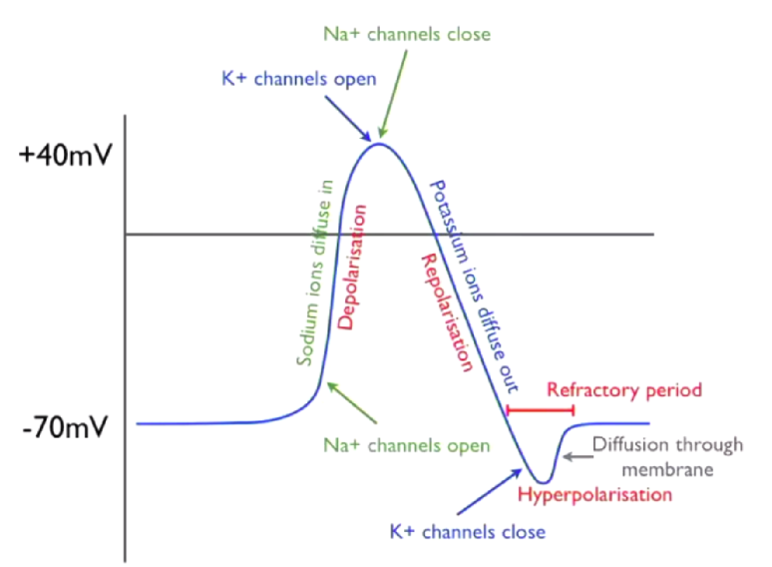ACTION POTENTIAL (AP)
  + Pulse-like wave that travels long excitable cell membranes
  + Travels via axon
  + All or none process (either: nothing happens, or all steps below occur, at about same mV values)
  + Repetitive process, travelling along length of axon in node of Ranvier
  + At rest, voltage in cell = -70V (resting potential)
    - Maintains this by pumping Na and K
  + If chemical signals received by dendrites are sufficient to cause voltage to get to threshold point (ie. -55mv)
    - Sodium channel opens = depolarization
    - Voltage increases to max point (40V)
    - After this point, sodium channel deactivates and K+ channel opens
    - Cells polarize to negative membrane
      * Tends to overshoot K channels remain open (while Na is inactive) membrane potential becomes more negative but overshoot will come back to resting potential = hyperpolarization
* 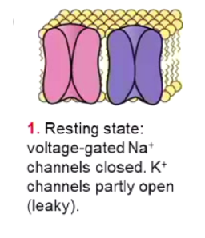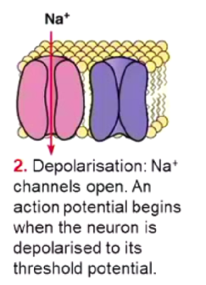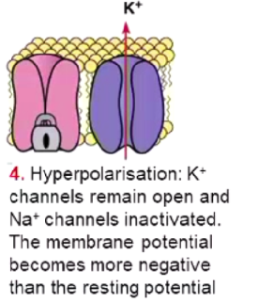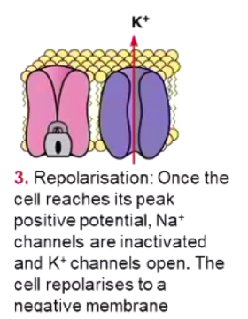MEMBRANE AND ION CHANNELS
  + All signals caused by chemical gradients and diffusion of cells among cell membranes
  + Inside cell = high levels of K+ ions and low levels of Na+ ions
    - Opposite on the outside
  + Membrane has separate ion channels for different ions
    - Ion channels differentiates between excitable tissue and normal tissue
    - Channels are picky and selective for specific ion species
    - Na channel only lets sodium ions go from outside to inside of cell
      * Effectively has three gates
        + One is voltage sensitive
        + Other is time sensitive

It will shut down after a certain period, independent of what voltage is across the membrane

* + - * + 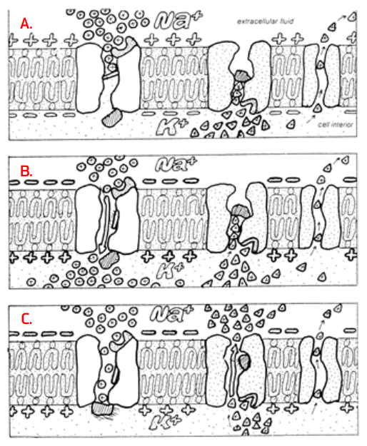Has an activation and deactivation gating variable
    - K channel only lets potassium ions go from inside to outside of cell
      * Single gate that opens depending on voltage across cell membrane
  + A,B, C are processes that occur when cell reaches ‘threshold’ (when a few sodium channels start to open)
    - (A) Na and K leak through membrane, bringing membrane back to resting potential
    - Na Opening inside of neuron more positive (as voltage increase, all sodium channels open) rush of Na into cell (B) after a period, Na channels deactivate/close
    - More Na+ increases positivity of channels enough for K channels to open repolarization (C): potassium ions diffuse into membrane increasing negativity of channel interior
    - When potassium channels open and close slowly Too much potassium goes inside = overshoot/hyperpolarisation
    - Refractory period = between time of hyperpolarisation to when membrane returns to resting potential
* CARDIAC MUSCLE
  + Duration of cardiac action potential is 100x more prolonged than in skeletal muscle/nerve impulse
  + 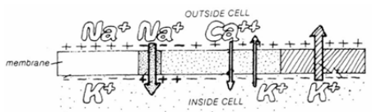Long refractory period Allows sustained contraction of cardiac muscle
  + Plateau sustained by slow Ca2+ entry and slow K+ flow out
    - When AP initiates, calcium ions flow as well
    - Ca ions maintain plateau elongated refractory period
* ELECTROCARDIOGRAMS
  + 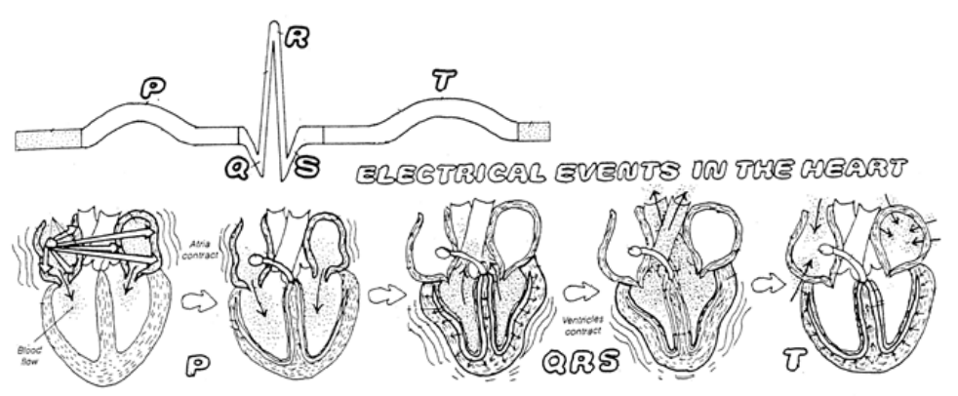Pacemaker in right atrium regularly create AP AP propagates from top to bottom of heart in controlled manner
  + Controlled electrical activity allows ECG to form and be detected at body surface
  + P – wave occurs when top of heart/atria contracts
  + QRS complex
    - Ventricles contact
    - Repolarization of atria is hidden under QRS wave (due to relatively smaller size)
  + T-wave occurs when ventricles repolarize/relax
  + ECG records cell potential of all cells during heart beating at certain timings (mV)
    - Signals can be disrupted by noise (eg. Squeezing body parts or breathing)
  + Interface is critical!!!
    - Shoving electrode nails in ourselves = v crude
    - # of functional channels increase = Better patient quality of life
    - 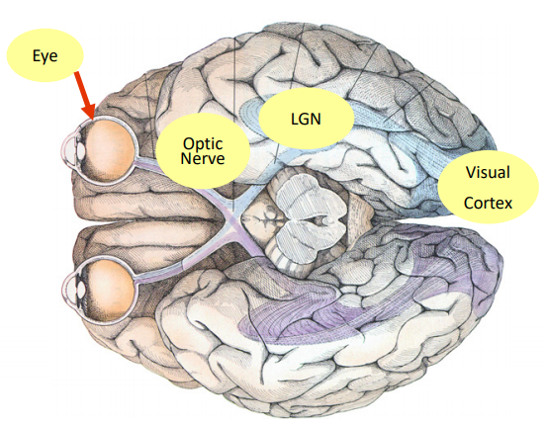Eg. Cochlear implants aren’t perfect substitutes, as they can’t distinguish between different pitches

PART 2: Neural Interfacing and neuroprosthesis

* THE HUMAN VISUAL PATHWAY
  + Light signals passes through cornea lens retina (back wall of the eye) optic disk lateral geniculate nucleus visual
  + Visual Cortex occupies a huge section of the brain because of the complexity of processing images
  + Left side brain = process images from RIGHT EYE, and vice versa
  + The function of non-retinal components of ocular anatomy is to maintain a focused and clear image of visual stimuli fixed on the surface of the retina
  + Lens + eyes + muscles = maintain stable image when head shaking
    - Vestibulo-ocular reflex causes eye movement
  + Three layers/tunics in eye structure
* TUNIC 1 = outside tunic = sclera and cornea
  + Sclera (white bit) maintains the eye globe
  + Anterior surface covered by conjunctiva (under eyelid; pink scaly thing)
  + Cornea (clear bit in front of eye) is non-vascular (no blood vessels) and continuous with sclera
    - Forms 15% of globe anterior
* TUNIC 2 = choroid, ciliary body and iris
  + Choroid = 85% of globe anterior
    - Provides blood/nutrients to the retina; connects to ciliary body and iris
    - Loosely externally connected to sclera and internally connected to retina
    - Most vascular part of the body (greedy of energy)
  + Ciliary body produces gel/aqueous humor and adjusts eye curvature to focus on nearby objects
    - Ciliary muscles help focus image on retina by changing its shape/curvature, but DOES NOT move lens back and forth
* 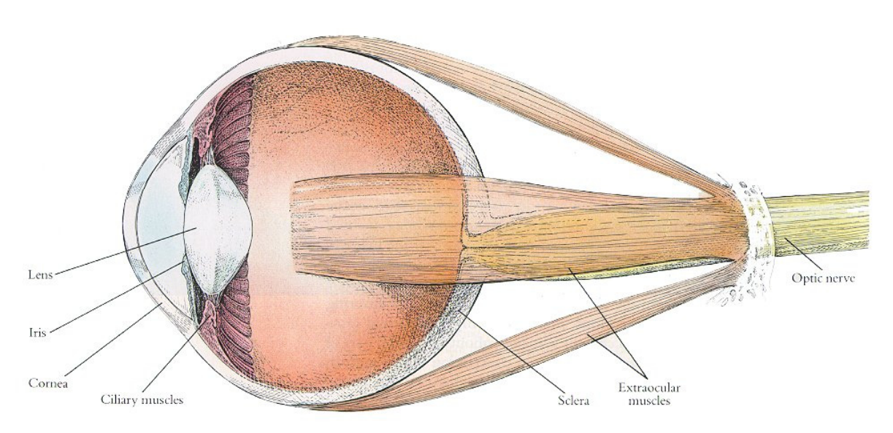TUNIC 3 = inner tunic = retina
  + Forms interior surface of eye form fovea centralis to ora serrate near ciliary body
  + Consists of 10 layers between choroid (outer surface) and vitreous humour (inner surface)
* CORNEA
  + Light enters at anterior surface of cornea
  + Approx. 2/3 of refraction/bending of light needed image focusing takes place at the air-cornea interface
    - Rest of about 1/3 occurs at lens
* LENS
  + Provides light bending power with the cornea
  + Main role is to change focal distance of eye, to allow focus on objects at various distances
  + Anterior surface changes shape, via contraction/relaxation of ciliary muscles
    - More Spherical = near objects
    - Flat = far
* IRIS adjusts amount of light on retina
* THE RETINA
  + From outer eye to inner:
    - Sclera
    - Choroid/blood supply
    - Pigment Epithelium (seal) provides nutrients from choroid to photoreceptors
    - 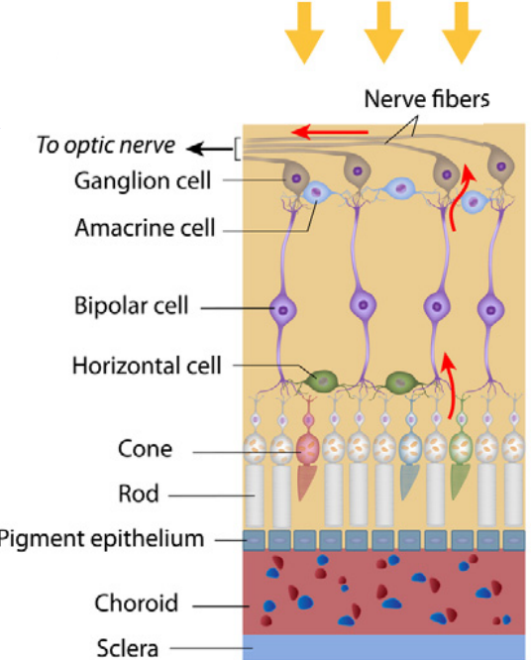Photoreceptors = rods and cones
      * Cones = colored light, works best at relative bright light
      * Rods = peripheral vision, higher sensitivity
        + In dark, rods have Na+ channels open and depolarize activates bipolar cells inhibits ganglion cells

Photoreceptors are still firing away while ganglion cells are turned off

* + - * + In light, hyperpolarizes rods inhibits bipolar cells activates/excites ganglion cells
      * When dim light, cones shut off
      * Light passes through cells hits photoreceptors photoreceptors transduce light into graded potentials horizontal + bipolar cells create an image feed it into ganglion cells
    - Retinal ganglion cell layer
      * Retinal ganglion cell (RGC) is a type of neuron located near inner surface of retina, to receive info from photoreceptors via two intermediate neuron types: bipolar cells and retina amacrine cells
      * Contains axons (no dendrites) that collect at optic disk
      * Does not synapse directly with photoreceptors; goes via bipolar cells
      * Situated eat the anterior (front) of retina
    - Intermediate cell layer
      * Between photoreceptors and ganglion cells
      * Consists of bipolar, horizontal and amacrine cells
      * In fovea (central vision); one-to-one correspondence between photoreceptor (cones) and GC
      * In periphery: 100-to-one correspondence between rods and GC [very concentrated]
    - Bipolar Cells
      * Exist between photoreceptors (rod and cone cells) and GC
      * Transmits signals from photoreceptors to GC
  + Sends difference in variables to the brain
    - Changes in light intensity
    - Differences in contrast

PART 3: Bionic Eye

* During eye degeneration, photoreceptors are lost
* 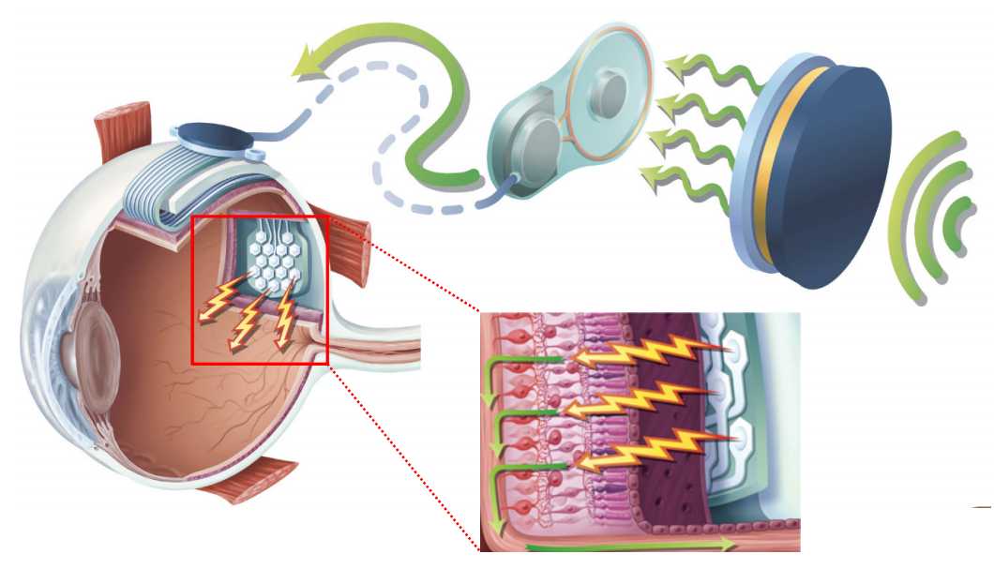PROBLEM: Create a device that can electrical stimulate ganglion cells to replace lost transduction effects from photoreceptors
  + Only work for some retinal implants
* Retina can be implanted in 3-4 different places
  + Epi-retinal implant = interior front surface of retina
  + Sub-retinal implant = detach retina; slide it behind retina and choroid
  + Subprachoroidal implant = behind choroid/blood supply, further from retina, but simply surgery :D
* REQUIREMENT: needs functioning ganglion cells and optic nerves not a complete solution for eye defects
* HOW DOES BIONIC EYE WORK?
  + External camera/processing system sends radio frequency signals to implanted transmitter behind ear, providing energy and information
  + No implanted battery due to high power consumption
  + Signals = two wires connected to another electronic piece place on top of eye globe exterior
  + Electronic connected to electrode array threaded back of retina (surprachoroidal space)
  + Current passes through electrodes to choroid through pigment epithelium stimulates ganglion cells and possibly bipolar cell sends signal to optic nerve and visual cortex
* DEVICE LONGETIVITY
  + Device coated with a layer of ceramic/platinum/polymer (potentially)/titanium prevents condensation/leaking/toxicity
  + Titanium lid/ring with ceramic base (Ai oxide)
  + Make it air/water tight
  + Device should last about 50 years
* IMPLANT ELECTRONICS
  + 98 channels/sites of neural stimulation Charge balanced biphasic current waveform used for safe stimulation
  + Needs chip to stimulate in safe manner
  + 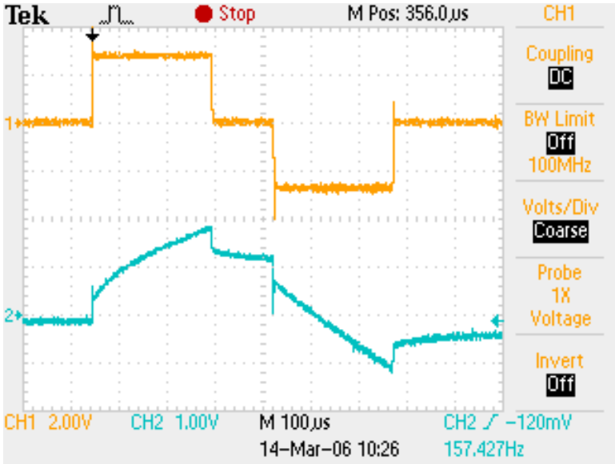When we inject a waveform (area under graph is amount of charged injected) cells reach threshold and fire action potentials
    - Creates voltage at interface > than at water window
    - Water gets hydrolyzed
    - Electrodes change their pH and dissolve
    - Neural tissue can die off
  + Thus, equal and opposite charge needs to be inject to keep neutrality
* SURGICAL PLACEMENT
  + Device sits within stable “pocket”, behind choroid
  + Significantly simplifies surgical approach